ER model Data Validation:

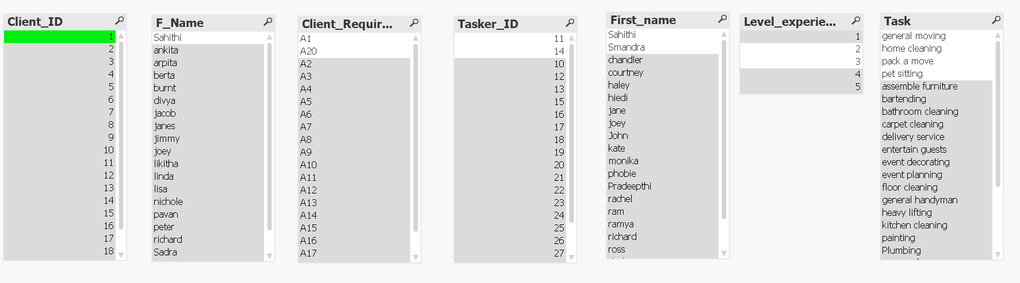

Dimensional Model Data Validation:

